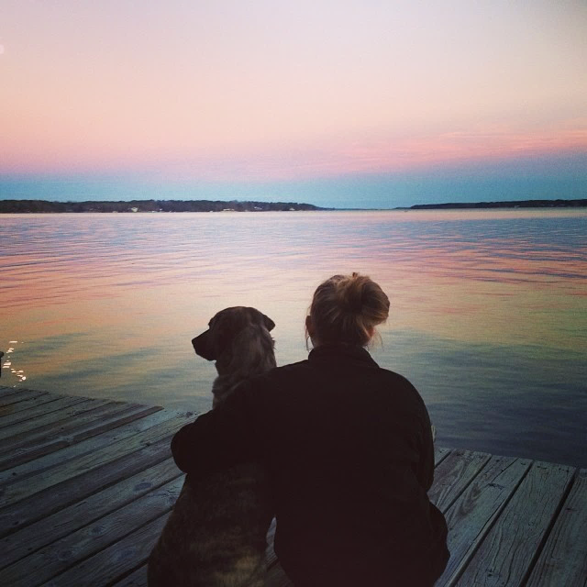 |  | Now Proudly Serving VIP in the Lake Norman area!  - November 1, 2016
now servicing lake norman and the surrounding areas |  | In This Issue: vip news, pet tips for the fall, VIP BLOG

News from Very Important Pets!
by Rebekah Wethington

The changing season is the perfect time for new beginnings, and to celebrate VIP (Very Important Pets) for twenty-five years of caring for your pets, we are excited to announce that on November 1st, 2016, we will be expanding our professional pet sitting services to the Lake Norman and surrounding areas; just in time for the holiday season!
If you know a friend or family member in this area, now is a great time to spread the word. We will be handing out a $10 coupon of pet cash for our new clients to use on their first pet sitting visit, (this excludes the consultation) which can be used now or in the future.
jj

t
Pet Quote of the Month

“Until one has loved an animal, a part of one’s soul remains unawakened.”

Anatole France
t

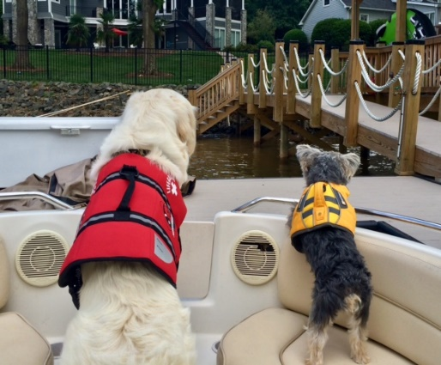

We are also searching for new professional pet-sitters in the Lake Norman area to join our team, so if you know of anyone who is interested in becoming a certified petsitter and lives in Cornelius, Huntersville, Davidson, or any of the surrounding areas, encourage them to visit our VIP website at vippetsitting.com, and we’d love to hear from them!

We are so thrilled to be expanding our services to the LKN area! So many people in this area love boating, skiing, swimming and just simply living and relaxing on this beautiful lake; we at VIP look forward to helping you and your fur babies enjoy and experience the best quality of life together!

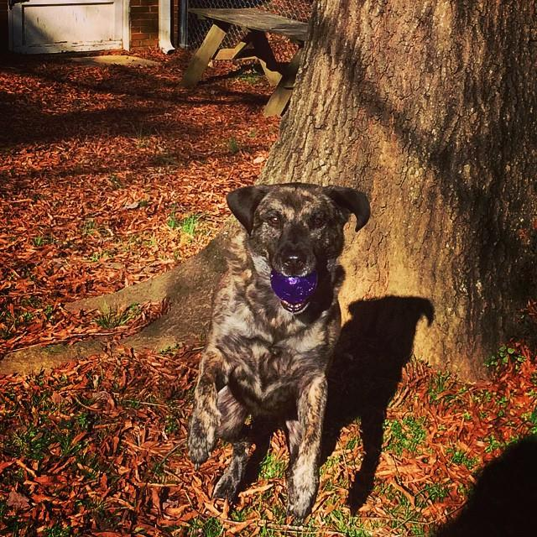

Pet Tips for the Fall

Stay informed!

To keep our beloved companions happy, healthy, and safe this autumn season, here are a few tips to prepare you and your fur babies for the chilly months ahead…
- You might be tempted to put away your pet’s flea medication for the winter months, but please keep in mind that fleas and ticks can be a recurring problem and may infect your pet at any time of the year. So, remember folks: Be hip – don’t skip!
- As cold weather pops up, so do the mushrooms! While you’re walking your dog, or playing fetch in the backyard, make sure you keep a sharp look out. Some mushrooms are highly toxic and if ingested, could be life-threatening. If you suspect that your dog or cat has ingested mushrooms, (common symptoms are vomiting, diarrhea, lethargy, yellowing of the skin, etc.) call Animal Poison Control and transport your pet to the vet as soon as possible.
- As the temperature drops, please be aware of cold weather poisons. Rodents will seek warmth, so many places in our community put out rodenticides to keep them away. Unfortunately, what’s harmful to the rodents can also be harmful to our pets. Antifreeze from vehicles can also be fatal to dogs and cats when ingested.
- While walking your pet at night or in the backyard, having them wear a reflective collar could help keep you and your pet safe from any dangerous wildlife lurking around- especially venomous snakes!
- Holiday candy and fall décor can be dangerous for pets if not kept out of reach – especially if your pet isn’t familiar with them. To avoid taking an unwanted trip to the vet, try your best to pet-proof your holiday home.
If you’re interested in reading more about VIP news, pet parenting tips and tricks, and other fun, pet-related happenings during the week, be sure to check out our new blog at the following web address:
http://vippetsitting.freeblog.site
Another great way to stay VIP-informed is by finding us on Twitter at @VIPPetsitting
As well as our Facebook page at https://www.facebook.com/VeryImportantPetsDurham

